How to Recover Word 2003 Password with Word Password Recovery Tool
Article Source: http://recoverlostpassword.com/article/recover-word-2003-password-with-word-password-recovery-tool.html

Every coin has two sides. Microsoft Word 2003 gives us the option to set a password on documents. The good news is we can protect our document’s security and prevent unlawful users from accessing your personal documents, but the bad news is you can easily forget or lost a document’s password. So it is critical that you remember your Word password. If you forget it, Microsoft cannot retrieve it. Now follow this tutorial to remove/change word 2003 password, and recover word 2003 password if you have forgotten or lost the password.
Remove or change password protection from word 2003 document

Note: Removing password for your Word 2003 document is based on the premise that you have used the password to open the password-protected document. If you forgot Word password, you have to recover word password with Word password recovery tool firstly.
Step 1: Open the password protected word file, on the “Tools” menu, click “Options”, and then click “Security”. The placeholder symbols, usually appears as either asterisks (*) or bullets in the Password to open box or the Password to modify box that represent the existing document’s password.
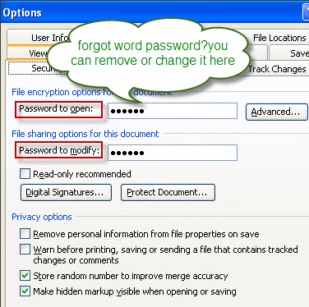
Step 2: Do one of the following：
- To remove word 2003 password, delete the highlighted symbols,and then click “OK” to exit the “Options” windows.
- To change word 2003 password, type the new password, and then click “OK”. Reenter the new password and then click “OK”.
Step 3：Resaved the document.

Recover word password with third-party software
A number of password recovery applications are available online for recovering word password if you forgot or lost the word password. Blow is some of them:
Word Password Recovery 5.0 is one of the most popular Word Password Recovery tool in the market, which helps to recover word password for opening or modifying of all versions from 97 to 2007.
Office Password Recovery 5.0 is an all-in one password recovery tool which can not only recover word password, but also other MS Office application such as Excel spreadsheets and Access databases.
Password Recovery Bundle is a must-have password recovery tool which can not only recover word password but also recover your windows password, other MS office application password, Email password as well as IE browser password.
Step 1: Download and install Word Password Recovery 5.0, Office Password Recovery 5.0 or Password Recovery Bundle. Save the file to your computer, double-click the exe file and then click Install.
Step 2: Launch the password recovery software and click "Open." Select your Word 2003 document that is password protected from the menu.
Step 3: Click Start. The software will begin its process, which may take hours depending on the length and complex of your password. When the program successfully recovered word password, the open password will displayed on the “File Opening Password” dialog.
